Handout: Push and Pull Factors in Migration from Mexico and the Northern Triangle Countries
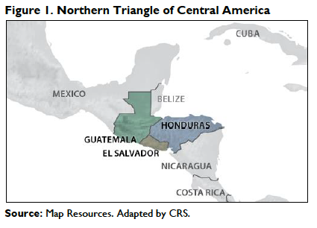

Recent migration across the southern border of the U.S. has emphasized the situation of people in the Northern Triangle, an area that effectively includes Honduras, Guatemala, El Salvador, and Nicaragua.

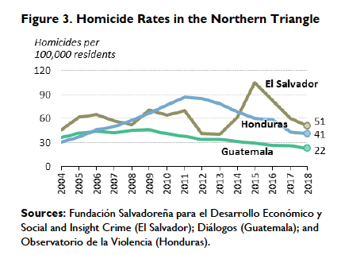
The civil wars—often funded by the United States as part of the Cold War—that wreaked havoc in Central America continue to impact the social, cultural, economic, and political situation in these countries. In particular, corrupt government institutions remain unable to alleviate poverty, establish social order, or protect citizens from criminal enterprises. It’s estimated that 76% of Guatemalans live in poverty and 27% live in extreme poverty (Meyer, 2019). Push factors in the decision to migrate include lack of access to safe communities, sexual violence and murder, the forced recruitment of youth into street or cartel level gangs, and “war taxes” imposed by gangs to move between neighborhoods. Pull factors include family reunification, economic opportunities, and a desire for stability. In an interview of Salvadoreans in the 2018 migrant caravan, 52% listed economic motivations, 18% listed violence and insecurity, 2% listed family reunification, and 28% listed a combination of the three as motivations for migrating to the United States (Meyer, 2019). The cartels that control the movement of drugs through South, Central, and North America also employ violence with impunity in the countries where they operate.

As a result of NAFTA (1994) and CAFTA (2006), market liberalization and U.S. agricultural subsidies have depressed the price of corn, causing subsistence farmers in Mexico and the Northern Triangle to lose their land and migrate for economic opportunities. Pressure from the global economy, including China, has also put pressure on manufacturing facilities in Mexico and the United States. It’s worth pointing out that wage depression, agriculture, the drug trade, and pressure from Chinese manufacturing are hemispheric rather than national challenges; however, the superior infrastructure, public institutions, and financial situation of the United States have made these challenges less paralytic here.

Sources:
Bejarano, Cynthia. Lecture. July 19, 2019. The University of Texas at El Paso.
McBride, James and Mohamed Alie Sergie. “NAFTA’s Economic Impact.” The Council on Foreign Relations. October 1, 2018. https://www.cfr.org/backgrounder/naftas-economic-impact. Accessed July 27, 2019.
Meyer, Peter J. and Maureen Taft-Morales. “Central American Migration: Root Causes and U.S. Policy.” The Congressional Research Service. June 13, 2019. https://fas.org/sgp/crs/row/IF11151.pdf Accessed July 27, 2019.

